# Maxson Bunker

Version 1.0

12/1/2003 11:02:00 AM

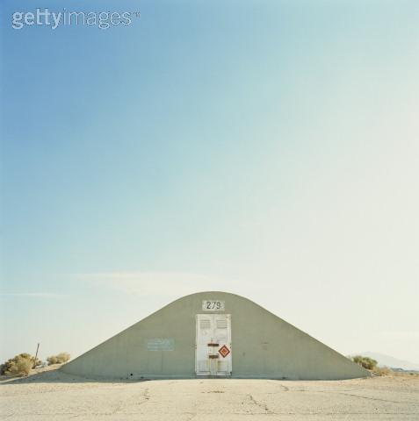

*"We're losing the war, we're losing technology to the wastes, and our inept commander can't do a damn thing about it! Well, some of us have taken steps to recoup our losses!"*

Devon Hill, the Circle of Steel.

#### Overview

**Maxson Bunker:** Built into the face of a cliff wall is what appears to be a camouflaged steel door. There is no apparent way to open the door. Further along the cliff wall is a natural opening into a small cave.

Maxson Bunker was a pre-war fallout shelter built by a senator for his family and himself. Unfortunately, the war caught him unawares and the bunker was never used. All but forgotten, the bunker location was passed down as a family secret from one generation to the next. Eventually a family member passed the secret on to Roger Maxson, who claimed it for the Brotherhood of Steel.

The bunker was intended to be used as a staging area for exploration teams scouting the east. However, once the war broke out with the New California Republic the bunker became a forward base of operations against Hoover Dam, an NCR outpost. The war effort has gone poorly for both sides. The BOS has superior technology, but the NCR has superior numbers of troops. As a result, the war has been at a stalemate for years. Morale on both sides has plummeted but the BOS has been severely affected.

The BOS has always believed themselves to be an elite organization comprised of the best that mankind has to offer in soldiers and technology. The fact that a large group of under trained and under equipped troops could hold their own against such superior forces was an eye opener for the BOS. The war, in their eyes, has now become a senseless waste of lives and resources. Many of the BOS troops have deserted and fled into the wasteland to find new lives, leaving the bunker occupied by a select few diehards.

In the wake of these troubles, a covert group of former BOS operatives has come into existence. Calling themselves the Circle of Steel, this group raids caravans and villages, confiscates any advanced technology they may have, and does so in the name of salvaging mankind from itself.

|  |  |  |  |  |
| --- | --- | --- | --- | --- |
| **MAP AREA** | **TRANSITION** | **MAP #** | **MAP SIZE** | **COMPLEXITY** |
| Bunker Entrance | Full Party |  | Small | Outdoor area with cave |
| Bunker Level 1 | Full Party |  | Medium | Typical vault |
| Bunker Level 2 | Full Party |  | Medium | Typical vault |
| Bunker Level 3 | Full Party |  | Medium | Typical vault |
| Circle of Steel Hideout | Full Party |  | Medium | Small village |

#### Area History

In the year 2067, Senator Todd Peterson decided to build a secret bunker to house himself and his family should war break out. Senator Peterson was a wealthy man in his own right, but lacked the funds necessary for such a project. Through secret dealings with Poseidon Oil and a covert branch of the government known as the Enclave, the final funding for the project was attained. A construction sight was chosen in southern Colorado and work began.

Ten years after the construction was completed, war did indeed break out. Senator Peterson was in Washington DC at the time and, much to his chagrin, was taken completely by surprise. The senator made a desperate attempt to gather his family and reach the bunker, but his small plane never arrived. The bunker might have remained lost were it not for a surviving member of the senator's family, Ben Schilling.

In the year 2077, Captain Roger Maxson left the Mariposa military base and traveled to the secret Lost Hills bunker for the purpose of establishing a new military order. He brought with him a loyal group of followers consisting of both military personnel and scientists. Among these was Corporal Ben Shilling. It was at this time that Maxson established the Brotherhood of Steel. As the Brotherhood grew they began to look into the possibility of expanding their operations. It was then that Ben Schilling revealed the location of the Senator Peterson's bunker. The location was filed for future use.

In the year 2231, Jeremy Maxson, was leading a thriving Brotherhood of Steel. Jeremy decided that it was time to expand BOS operations into the east. He sent an expeditionary force composed of five paladins to confirm the location of Peterson's bunker. The expedition leader, Andrea Brixley, discovered the bunker, disabled its security, and opened it for habitation. For over a decade she and her fellow paladins explored the east and forged relationships with many of the tribes that inhabited the area.

In the year 2242, Jeremy Maxson renamed the bunker after his famous ancestor, Roger Maxson. He then sent a full compliment of troops for occupation. Andrea Brixley was promoted to Elder, given the rank of General, and placed in charge. The remainder of her exploratory team was given the title of Elder as well. It was not long afterward that the war with the New California Republic was announced.

For years the war waged on and was considered a victory for the Brotherhood of Steel. However, no matter how many troops fell to the Brotherhood's superior technology, the NCR always seemed to have more replacements available. The Brotherhood, however, was not so fortunate. Being an elitist group, replacements were short in arriving. It soon became obvious that the Brotherhood was doomed to loose the war to the NCR's greater numbers. Moral at the bunker began to falter as the war seemed more and more hopeless. Eventually the inevitable happened. Lower ranking members of the Brotherhood began to desert their posts.

In an effort to end the war once and for all, the Brotherhood began to use newly discovered subversive technology known as StealthBoys. These devices could create a field of energy that would bend light around the user, thus making him virtually invisible to sight. This allowed Brotherhood operatives to penetrate deep into NCR territory for the gathering of intelligence. However, it was soon discovered that the devices had severe side effects. Paranoia, delusions, and eventual schizophrenia were the major ones. The Brotherhood disallowed the use of StealthBoys and once again fell behind in their war effort.

Now the Brotherhood of Steel is facing yet another problem. The side effects of the StealthBoys were not discovered until the team using them had already begun to feel their effect. When the team was disbanded, paranoia over the reason began to set in and the team plotted against their leaders. They stole the StealthBoys, fled the bunker as deserters, and formed a covert group known as the Circle of Steel. The goal of the COS is to recover lost technology and rebuild the glory of the Brotherhood at any cost.

#### Area Composition

The Bunker Entrance:

This area consists of a cliff wall with a camouflaged hanger set into it. Nearby is a cave entrance that leads to the bunker proper.

The Bunker Level 1:

This level contains the barracks, training room, armory, motor pool, and medical facility of the bunker.

The Bunker Level 2:

This level contains the living quarters for senior personnel, the kitchen, the dinning area, a meeting area, the computer room, the water purification plant, and the brig.

The Bunker Level 3:

This level was to be the private quarters of Senator Peterson and his family. It contains a computerized library, an office, a bedroom, and a power plant.

The Circle of Steel Hideout:

This is a random map composed of a small rural town/farm. It is here that the Circle of Steel will be confronted.

### Locations

#### The Bunker Entrance:

This is an outdoor area, mostly rocky in appearance. To the north is a small cliff wall. Built into the cliff is what appears to be a partially concealed hangar door. This door provides entry to the motor pool on the first level of the bunker (the door cannot be opened from the outside). To the right of the hangar door is a small cave mouth. The main entry to the bunker can be found within the cave.

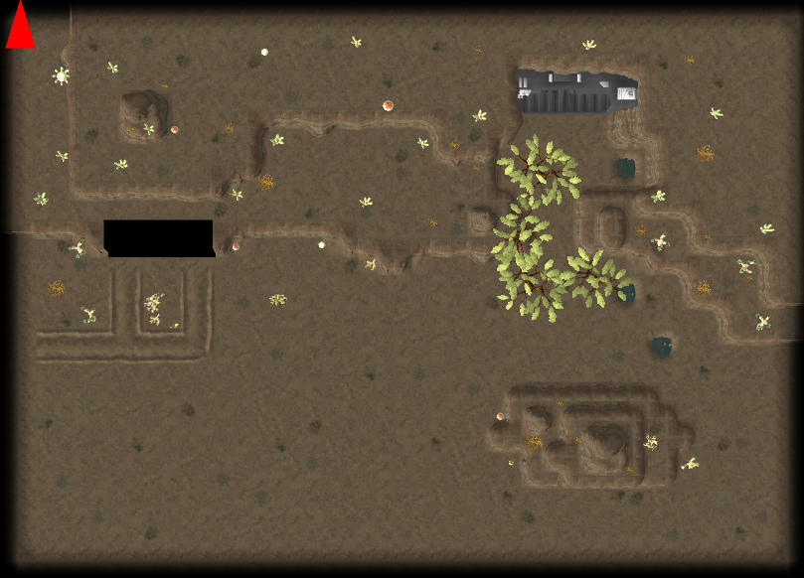

The entry door is a standard Vault-Tek model with an access computer just to the left. If the player tampers with the computer a pair of guards will come to investigate. The player will be invited into the vault after a brief questioning. He will be immediately escorted to the medical center for disease testing. Upon passing the test he will be given partial access to the base.

#### The Bunker L1:

This level of the bunker is composed of the barracks, the gym, the armory, the motor pool and the medical center. This level is lightly populated with guards as well as some key personnel.

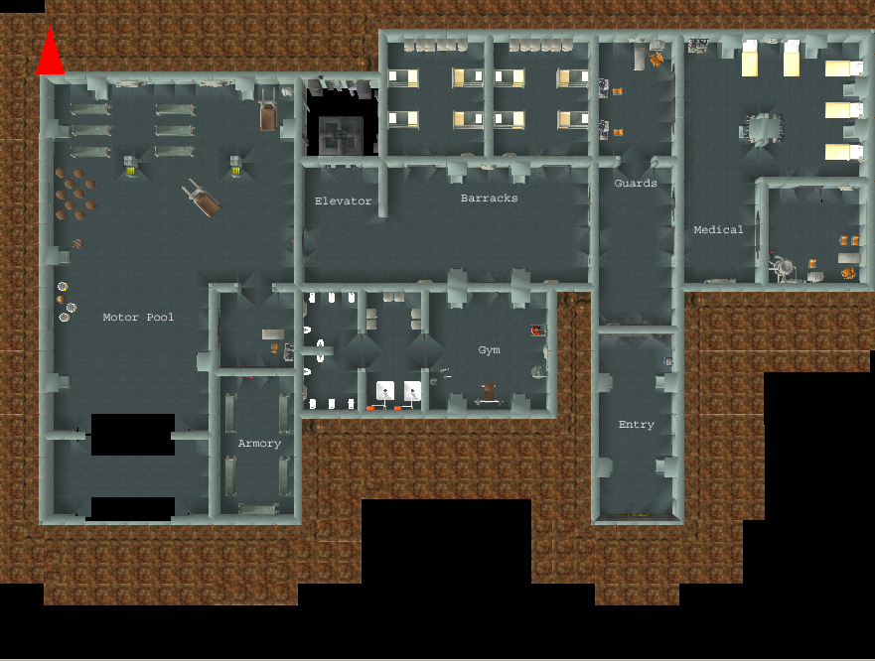

Upon entering the level, the player will be escorted by two guards. He will be taken to the medical center to be examined by the doctor, Sarah Whatley. The guards will return to their post at the guard station. Sarah will ask the player to cooperate. If he does not, she will call for the guards to escort him from the base. The player will not be allowed back in. If the player cooperates then Sarah will reveal plot critical information to the player for this area. The player will be locked in dialog mode until the critical information is given. Afterwards the player will be given limited access to the base. At this point the player will have access to all areas on this level except the armory. This area is locked.

The player can meet the following plot critical people on this level:

Sarah Whatley, the doctor. She will set up the initial plot. Reggie Billings, the paladin. He will be able to answer some of the player's questions about what is going on in the bunker. Edward Whatley, the mechanic. He can answer some of the player's questions as well as issue a few repair quests. Taking the quests will give the player more access to the base. Devon Hill, the quartermaster. He can answer some of the player's questions as well. Devon is also one of the main protagonists in the plot. At some point he will attack the player and must be killed in order for the plot to progress. In general, all of the above mentioned characters play a role in the plot of the area. The questions that they can answer will change as the player progresses through the base.

The player can meet the following non critical people on this level:

Various guards of differing rank.

Plot information: The base commander, Andrea Brixley, is suffering from a debilitating illness that Sarah has been unable to diagnose even with the help of the autodoc. Unless her ailment is diagnosed and a cure found, the commander will die. It is only through the pursuit of the solution to this mystery that the player can work his way through the different levels of the base. However, once the mystery is solved the rewards will be great.

#### The Bunker L2:

This level of the bunker is composed of the senior officer's quarters, the kitchen, dinning room, meeting room, a private office, the computer room, the water plant, the brig, and the secure elevator to the next level. This level is lightly populated by guards as well as some key personnel.

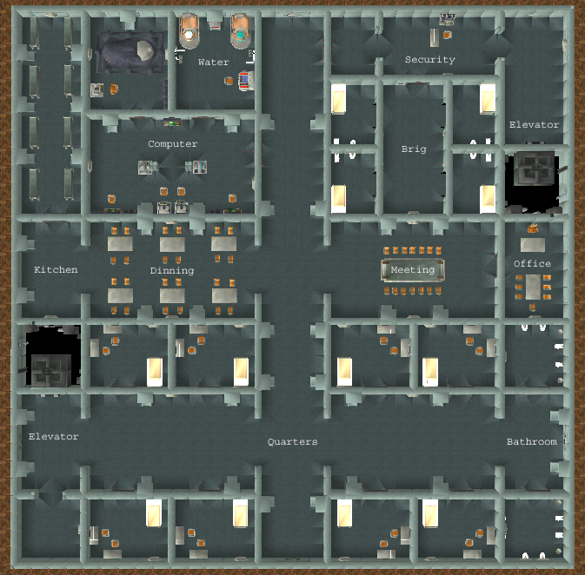

There are two ways that the player can gain access to this level of the base. First, he can help Sarah Whatley solve the mystery of the base commander's illness. This is unlikely to occur right away unless the player has good medical knowledge. Second, he can be on a quest from Edward Whatley to try and repair some of the malfunctioning equipment down here. They player will not be allowed to progress to the next level of the base until he solves the mystery of the commander's illness.

The player can meet the following plot critical people on this level:

Glenn Deering, the paladin. He will answer the player's questions and help unfold the plot in a very limited fashion. Traci Niels, the paladin. She will answer the player's questions and help unfold the plot in a very limited fashion. Jerry Corsetti, the paladin. He will answer the player's questions and help unfold the plot in a very limited fashion. Tamara, the cook. She is a major plot character. Through her the player can gather information vital to solving the mystery of the commander's illness. Jon, the cook. He is a major plot character. Through him the player can gather information vital to solving the mystery of the commander's illness. Davis Hewitt, the scribe. He is a major plot character. Through him the player can gather information vital to the mystery of the commander's illness.

The player can meet the following non critical people on this level:

Various guards of differing rank.

#### The Bunker L3:

This level of the base is composed of General Brixley's quarters, her office, her library, the foyer, and the base power plant.

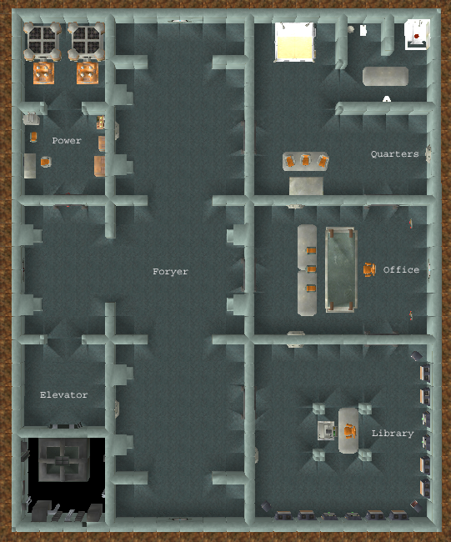

There is only one way for the player to gain access to this level of the base. He must solve the mystery of the commander's illness and be summoned by her. If he then agrees to work for the commander, he will be granted full access to the base and all its facilities. Other than General Brixley herself, there are no plot critical characters on this level of the base.

The General will be very grateful for the player's aid in her recovery. She will offer him a reward for his services and then ask for his help in solving certain mysteries. The final reward for the player's diligent work will be membership in the Brotherhood of Steel, a suit of Brotherhood armor, and a weapon fitting the player's rank and station.

The following plot critical quests can be gained:

1. Find who poisoned General Brixley. This will be revealed to be Devon Hill. In dialog with the quartermaster, the player will learn of the Circle of Steel.
2. Find Devon Hill's contacts. This will be necessary in order to locate the hideout of the Circle of Steel.
3. Find and eliminate the Circle of Steel.
4. Sue for peace and end the war with the NCR

#### The Circle of Steel Hideout:

This is a random village that was wiped out by the Circle of Steel and then turned into a base of operations for their raids. The player will be required to lay siege to the village and eliminate the Circle of Steel soldiers that are entrenched here.

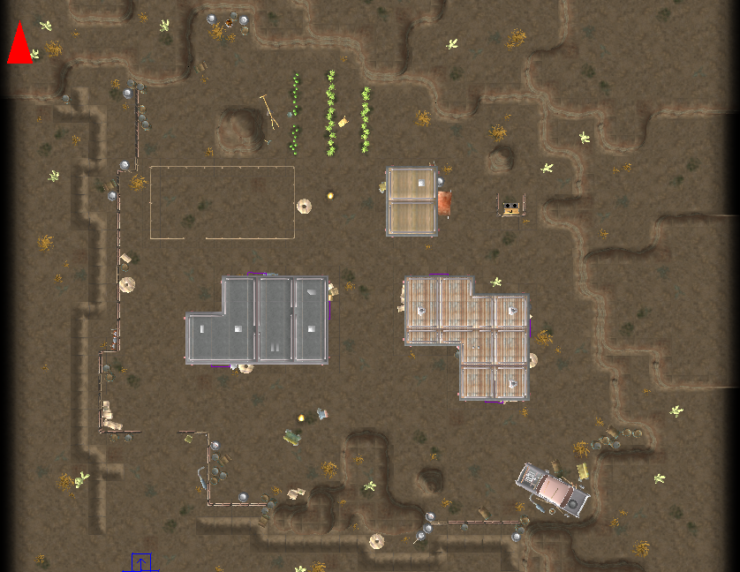

This village was chosen by the Circle of Steel for two reasons. First, they had the misfortune of owning a pre-war water evaporation device. This advanced piece of machinery was able to take water out of the hot desert air and store it for irrigating the meager crops of the village. Through proper rationing, it was able to provide water for the entire village as well. Second, the village was found to be in a very defensible area.

This location should be set up as a tactical combat area. Guards will be stationed near the single entry point and patrol the fences regularly. Small guard stations are scattered about that give clear angles of view over large areas of the village. Each of these stations is equipped with a mini-gun for maximum effect.

#### Art Requirements

There is nothing unique in this area. It can use standard items and tile sets that any vault/village area will use.

#### Tile Set

The following sets will be needed: junk town, desert, crops, and a vault-like set.

#### Critters

This area will use the standard human models and such.

#### Generic Scenery Objects

The following generic objects will be needed: desert trees, plants, rocks, ruined machinery, vault tech stuff.

#### Specific Scenery Objects

The following specific objects will be needed:

Entry:

* 1. Hangar door.

#### Dynamic Scenery Objects

The following specific objects will be needed:

Bunker:

1. Forklift
2. Air vent
3. Computer terminal
4. Computer memory core
5. Water purification thing

#### Area Photo



#### Town Map In Pipboy

To be determined

#### Scripted Scenes Or Movies

1. When entering the vault the player will need to be escorted by guards to the medical center.

### Cast Of Characters

**Andrea Brixley**

Andrea began her career in the Brotherhood of Steel as a scout/explorer. She was originally sent east to confirm the existence of Maxson Bunker and to use it as a staging area for her explorations. She was accompanied by a team of four paladins.



After the war broke out between the BOS and the NCR, Andrea was promoted to commander and placed in charge of the bunker. She also received the title of Elder Paladin, as did her four companions. Andrea is not comfortable with leadership and would prefer to spend her time exploring. She isn't very organized and is content to let people do what they are best at with little supervision. Fortunately, her supporting staff recognizes her flaws and cover for her.

Andrea's most ardent supporter is her best friend and fellow paladin, Glenn Deering.

**Glenn Deering**

Glenn began his career as a junior scout. He was one of the original team members who began to explore the east with Andrea Brixley. He found his superior to be very confident in the wilds and he learned a lot from her. He soon began to hold her in the highest respect and this eventually turned to love. However, Andrea's promotion to commander placed him in an awkward position and he has steadfastly refused to confess his feelings for her.



Glenn is very dedicated and loyal. He has a much laid back personality and rarely allows anything to upset him. He is a hard worker and oversees the basic functioning of the base and its personnel. He also recognizes his commander's lack of organizational abilities and discretely handles anything that she overlooks or forgets.

**Jerry Corsetti**

Jerry began his career as a grunt and quickly worked his way up the ranks to paladin. He is a competent warrior as well as a decent strategist. His accomplishments soon earned him the rank of squad leader and he was assigned a special squad. He and his select troops are sent in when situations demand special attention and tactics. In other words, they are a clean up crew.

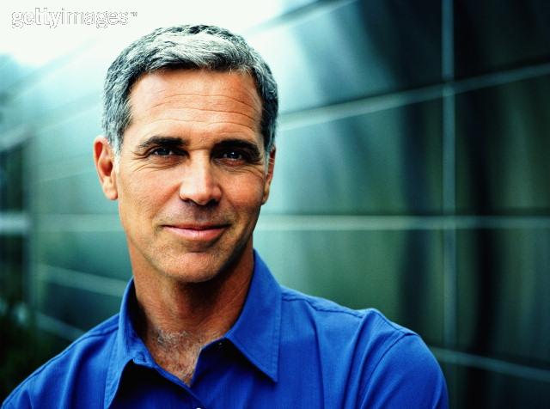

Jerry is very proud of his squad and their accomplishments. He will often brag, loudly, about his squad and how important they are to the Brotherhood. Jerry has a very youthful attitude despite his age. He believes that if you take the time to grow up you'll grow old, and then it's time to die.

Jerry is not pleased with the base commander, Andrea Brixley. He devised a plan for ending the war with the local NCR once and for all, but could not get approval from the commander. She felt that it was a borderline suicide mission and, despite his tactical reputation, would not allow it. He now believes that her policies in regards to the war are lax and detrimental to the Brotherhood in general. He would like to see the commander replaced by Traci Niels who proclaims a more proactive solution to the war.

**Reggie Billings**

Reggie began his career as a weight trainer and unarmed combat specialist. He joined the Brotherhood of Steel in his late twenties and soon began training the troops. When he learned of the expedition to explore the east he quickly volunteered. He felt that he needed a change of pace and the eastern lands seemed like the ticket.



Reggie is getting up there in years and is no longer the man he used to be. He realizes this and tends to take things easy now. Although he is still training the troops, he finds that he just can't go toe to toe with them himself. He now pairs them off with one another during training and is content to watch from the sidelines.

Reggie is a very friendly and open individual. He goes out of his way to stay on everyone's good side. He believes that the fewer enemies you make, the less you have to look over your shoulder. He just wants to get along.

**Traci Niels**

Traci began her career in the Brotherhood as a scribe but tired of the technical side of life. She asked to be placed in a combat role and was given the chance to prove herself. She was found to be a competent combatant who also had the advantage of being able to repair equipment on the fly in the field. She worked her way up the ranks and soon earned the title of Elder.



Traci is a headstrong no holds barred kind of woman. She is opinionated, she knows it, and she doesn't care. She will often voice her opinion tactlessly whether or not it is asked for. She is considered a bitch by most anyone who knows her and she could care less.

Traci is not pleased with the base commander, Andrea Brixley. She finds her unorganized, flighty, and generally incompetent. She knows that, were it not for Glenn's careful attention, Andrea would fall apart. Traci would like nothing more than to replace the commander with herself and she has made this known to all. However, Traci is loyal to the Brotherhood and its line of command. She follows her commander's orders dutifully.

**Tamara Young**

Tamara is a pretty young woman with no particular skills other than cooking. She grew up in a small wasteland town and, although intelligent, had no opportunity to improve her place in life. She eventually met a young man, fell in love, and was thinking of settling down. However, life in a small town was still very unappealing and she wanted out.



Tamara got her opportunity when she was offered a job as a cook for a military organization. It seemed that they were short on personnel and needed someone competent to take on the task of feeding the troops. She quickly accepted the position and broke the news to her new boyfriend. She was quite happy when he agreed to join her and help her out in her duties. After clearing everything with her new employer, she set out for Maxson bunker.

Tamara is intelligent and bright, but she suffers from the foolishness of youth. Oftentimes she does things just because others are doing it. She doesn't take the time to think things through.

**Jon Young**

Jon is a young man with a single purpose. He wants to have fun in life. He uses women for pleasure, but he's at least honest and admits this before becoming involved. He uses recreational drugs, but stays away from the hard stuff. He's willing to do an honest day's work when he has to and takes on odd jobs.

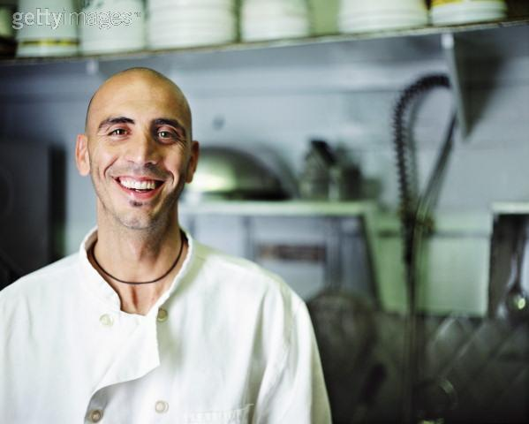

Jon enjoyed his carefree lifestyle until he met Tamara. He was honest with her and told her exactly what he wanted from her. She agreed and all was well. Much to his surprise, he found that he couldn't get her out of his mind. When she announced that she was leaving town for a new job, Jon asked her to take him with her. He was willing to give up his lifestyle if he could spend his days with her. Tamara accepted.

Jon is a good man despite his use of drugs. He loves Tamara, respects her, and wants to make her his wife. Although they are not married, they agreed to share Jon's last name.

**Davis Hewitt**

Davis began his career as a Brotherhood of Steel scribe. He is brilliant, although somewhat lazy. He knows that people of his caliber are in high demand and he takes advantage of the fact. He sees the BOS as a means to an end and nothing more. He thinks it will sound good on his resume'.

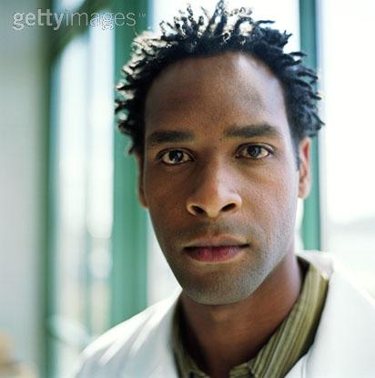

Davis was not at all pleased when the war broke out with the NCR. Even though he knew he was part of a military organization, the thought of having to fight and getting killed in a war never crossed his mind. When he heard that there was going to be a desertion from the bunker, he quickly joined in. Unfortunately, when the time came to leave he was the only one who was caught. When questioned about his reasons for leaving he claimed he was disillusioned by the war and the tarnished record of the Brotherhood. He was ashamed to admit his real reasons.

Davis is not a coward. He simply wants to live and let live. He doesn't believe in war unless the enemy is on your doorstep or a proven threat. In such a case he would fight to defend his country. He just doesn't see the war with the NCR as being that type of war.

**Devon Hill**

Devon began his career as a grunt. Over several years with the Brotherhood of Steel he proved his dedication and combat worthiness. He was given several promotions and received several awards for his accomplishments.



Devon was chosen to participate in a covert stealth team using untested devices. He readily agreed and excelled in the training. Once again he distinguished himself in completing his assignments. Unfortunately, there was no recognition for his efforts because his work was secretive in nature. However, he recognized this fact and accepted it.

Devon was the unfortunate victim of the stealth devices known as StealthBoys. Prolonged use caused the user to suffer paranoia, delusions, and eventual schizophrenia. When this was discovered, the devices were banned and the team disbanded. However, it was not known that the team had already begun to suffer the effects of the device. Thinking the disbanding of their team to be a conspiracy, they decided to steal the StealthBoys and form a new covert operation called the Circle of Steel. Devon was left at the base as an undercover operative to cover up the theft of the StealthBoys.

**Sarah Whatley**

Sarah joined the Brotherhood of Steel because her brother, Edward, became a member. When their parents died, Sarah promised to look after her younger brother and take care of him. If this meant following him into the Brotherhood, she was more than willing to do so.



Sarah had no liking for the military and just couldn't seem to excel at any of the skills required to get ahead. Everyone knew that she was there because of Edward. And everyone also knew that there was no getting rid of her unless her brother went with her. So, everyone found something for Sarah to do until she took an interest in the medical field. Much to everyone's surprise, including her own, she showed the potential to become a competent doctor. Sarah's place in the world had been discovered.

Sarah is currently an intern at the base. Unfortunately for her, the former staff deserted and she has been left to further her career on her own. She takes her work seriously and is studying everything she can find related to medicine in the bunker's library.

**Edward Whatley**

Edward began his career as a mechanic's assistant in a small town. He showed great potential to become a mechanic himself, but his mentor jealously guarded his secrets. Edward's sister, Sarah, worked hard to earn enough money to buy her brother the education that he needed. Her hard work paid off and he became a master mechanic.



Edward was discovered by a Brotherhood of Steel recruiter and offered a position in the order. He decided to accept under one condition, his sister was to be allowed to join as well. Although this was unheard of, it was agreed upon. The order did not want to lose someone as skilled as Edward.

Edward is a simple man and is pleased with his life. He loves his sister and watches over her just as much as she watches over him. The two siblings are very close and neither one goes anywhere without the other.

### Scripting

#### General

I have placed scripting sections at the end of each area description.

#### Cut-scenes

I have placed scripting sections at the end of each area description.

### Monster Roster

The player will encounter no monsters at the bunker other than the eventual showdown with the Circle of Steel.

|  |  |  |
| --- | --- | --- |
| **MONSTER** | **NUMBERS** | **DIFFICULTY** |
| Circle of Steel | 12+ | Medium to hard |
|  |  |  |
|  |  |  |
|  |  |  |
|  |  |  |

#### Random Encounters

### Emotional Porn

This section sets up all the emotional role-playing opportunities present in Maxson Bunker.

#### Drama

Someone has poisoned the base commander. The player can wander about the base, interview people, perform tasks, and unravel the mystery as he does so.

#### Moral Dilimmas

I'm not sure at this time.

#### Role-playing Tests And Epithets

We can check karma via the player's responses in dialog and the actions he takes in dealing with the Twin Mothers.

#### Ties To Overall Game Themes

This is an optional play area. Although there will be ties into the game via Hoover Dam, it is not necessary to play this area.

#### NPC Companion Uses

There are no specific NPC uses in the Maxon Bunker area.

### Quests

#### Main Quests

There are a few quests in the Ouroboros area. Most of them are not really required; they are just there for story purposes and to give the player something to do. I have listed them in no particular order.

* 1. Cure the commander:

This quest starts indirectly by talking to the doctor, Sarah Whatley. It's not a quest that the character is asked to take on, it is just indirectly assumed through dialog. However, if the character has medical skills then they can choose (with moderate skill) to aid Sarah and solve this quest initially. Otherwise, the player must take on a few indirect quests, get access to the base, and then find the cure through dialog with various people.

* 1. Find the poisoner:

One the commander is cured she will ask to see the player. She wants to know who poisoned her and why. This quest is assigned and can be completed through dialog with various people.

* 1. Find contacts:

Once the poisoner is found, the player will be asked to find his associates. This quest will lead the player to Hoover Dam. It also has the potential to lead to the COS, the "bad guys" in this scenario.

* 1. Find COS:

After finding the location of the COS the player will be asked to eliminate them.

* 1. Peacemaker:

At this point the player will be asked to end the war between the Brotherhood of Steel and the New California Republic.

* 1. Repair Forklift:

This is an incidental quest that the player is asked to perform. It gives them something to do.

* 1. Repair Vents:

This is an incidental quest that the player is asked to perform. It gives them something to do.

* 1. Repair Computer:

This is an incidental quest that the player is asked to perform. It gives them something to do. However, this quest will also give them access to the second level of the bunker. Even if the player is unable to solve the quest, he can take it just for the access.

* 1. Repair Memory:

This is an incidental quest that the player is asked to perform. It gives them something to do. However, this quest will also give them access to the second level of the bunker. Even if the player is unable to solve the quest, he can take it just for the access.

* 1. Repair Water Chip:

This is an incidental quest that the player is asked to perform. It gives them something to do. However, this quest will also give them access to the second level of the bunker. Even if the player is unable to solve the quest, he can take it just for the access.

* 1. Establish trade:

When all is said and done it will be revealed to the player that the bunker is no longer receiving supplies from the BOS in the west. A deal will need to be made with one of the caravans of Hoover Dam to provide supplies to the bunker.

* 1. Find the codes:

Devon Hill changed all of the codes on the bunker armory. Without access to weapons and armor, the Brotherhood is helpless. The player will be asked to track down Isaac Gant, a former BOS member, who knows the reset codes to the armory.

#### Merchant Quests

There are no merchant quests in this area.

#### Floating Quests

There are no floating quests in this area.

|  |  |  |  |  |  |  |  |  |
| --- | --- | --- | --- | --- | --- | --- | --- | --- |
| **Area** | **Quest Name** | **Designer** | **DStatus** | **Script** | **SStatus** | **Log Stat** | **Passable** | **QA 100%** |
| **Maxson** |  |  |  |  |  |  |  |  |
|  | **Cure the Commander** | Deiley | 0 | ? | No | 0 | No | No |
|  | **Find the Poisoner** | Deiley | 0 | ? | No | 0 | No | No |
|  | **Find Devon's Contacts** | Deiley | 0 | ? | No | 0 | No | No |
|  | **Find the COS** | Deiley | 0 | ? | No | 0 | No | No |
|  | **Peacemaker** | Deiley | 0 | ? | No | 0 | No | No |
|  | **Repair Forklift** | Deiley | 0 | ? | No | 0 | No | No |
|  | **Repair Vents** | Deiley | 0 | ? | No | 0 | No | No |
|  | **Repair Computer** | Deiley | 0 | ? | No | 0 | No | No |
|  | **Repair Memory** | Deiley | 0 | ? | No | 0 | No | No |
|  | **Repair Waterchip** | Deiley | 0 | ? | No | 0 | No | No |
|  | **Establish Trade** | Deiley | 0 | ? | No | 0 | No | No |
|  | **Find Armory Codes** | Deiley | 0 | ? | No | 0 | No | No |

### Sound Requirements

#### Music

The Bunker is the home to the Brotherhood of Steel. I think the music should reflect the knights of chivalry that the Brotherhood is supposed to represent.

#### Basic SFX

|  |  |
| --- | --- |
| **AREA** | **SOUND REQUIREMENTS** |
| **Entry** | **MUSIC DESCRIPTION** |
| The standard outdoor wasteland music used in Fallout 1 would be fine. |
| **BASIC SFX** |
| General background desert noises |
| **WALLA SFX** |
| None |
| **Level 1** | **MUSIC DESCRIPTION** |
| This is the Brotherhood of Steel. Although they have fallen on hard times of late, I still think the music should reflect the grandeur of the knights of old that they represent. |
| **BASIC SFX** |
| Standard vault |
| **WALLA SFX** |
| None |
| **Level 2** | **MUSIC DESCRIPTION** |
| This is the Brotherhood of Steel. Although they have fallen on hard times of late, I still think the music should reflect the grandeur of the knights of old that they represent. |
| **BASIC SFX** |
| Standard vault |
| **WALLA SFX** |
| None |
| **Level 3** | **MUSIC DESCRIPTION** |
| This is the Brotherhood of Steel. Although they have fallen on hard times of late, I still think the music should reflect the grandeur of the knights of old that they represent. |
| **BASIC SFX** |
| Standard vault |
| **WALLA SFX** |
| None |
| **Circle of Steel** | **MUSIC DESCRIPTION** |
| This is a wasteland village that the Circle of Steel has taken over/destroyed. This will be a tactical combat area so some music reflecting that fact would be nice. |
| **BASIC SFX** |
| Standard outdoor. |
| **WALLA SFX** |
| None |

### Map And Map Key

The maps are in the locations section above. I'll have to move them down here.