Mesa Verde (Ciphers)

Version 1

11/24/2003 3:50:00 PM

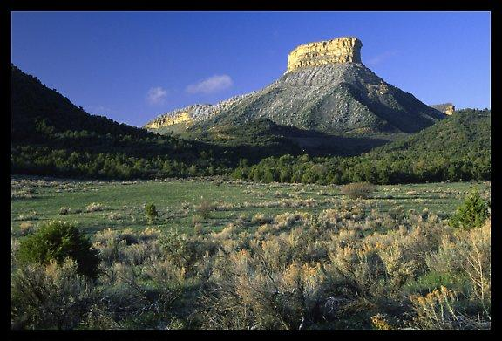

OVERVIEW

Hidden away in the shadows of a large cliff, near the top of a mesa rising from the desert floor, is the village of Mesa Verde. It is the home of the Ciphers, a.k.a. the Painted People, thanks to their extensive use of body paint. They're one of the smallest tribes in the area, but their hard-to-reach village on the mesa enables them to hold out against superior numbers of aggressors.

The Ciphers are unusual for tribals because they're skilled in mathematics and electronics, thanks to the extensive schematics on the walls of their village. They don't realize it, but they have the schematic for a chip necessary to release the remaining the rocket at Bloomfield from its docking clamps. If the clamps aren't released, the rocket goes nowhere and will most likely explode on the launchpad. Building the docking clamp chip is critical path.

This area consists of four maps:

MAP AREA | TRANSITION | MAP NAME | MAP SIZE | COMPLEXITY
1. Canyon | Full-party |  | Medium | Low – mesa tileset
2. Caves | Full-party |  | Small | Low – caves tilesets
3. Village | Full-party |  | Medium | Medium
4. Mesa Top | Full-party |  | Small | Medium – one or two unique metatiles

Potential Geometry Changes: There is an unstable cliff in the Canyon, near the Viper camp. A character with a good Traps skill (or just a really lucky one) can use explosives to cause the cliff to collapse on the Vipers. In addition, there probably should be a big, blackened crate where the Viper camp used to be if the PC fires the Laser Cannon at the Vipers.

MAP FLOW
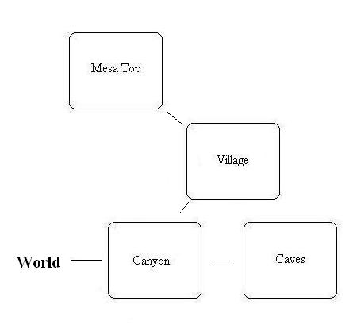

AREA BACKGROUND

In the weeks following the War, a group of scientists and soldiers based at the atomic laboratory at Los Alamos, New Mexico, wandered north with a band of other survivors (looking a bit like the group in The Stand), looking for a place of relative safety. They assumed that they were the only "civilized" people left, since everyone else they encountered attacked them, trying to take their food, water, and clothes. When they discovered one of the ancient pueblos at Mesa Verde, they decided to set up camp there.

The group carried only a limited amount of technology with them. The soldiers had pistols and rifles, and the scientists carried one barely working computer, enough parts to build several water makers and a crude wind turbine to power them, several lead-lined boxes containing enriched uranium, and a small supply of medicine. The rest of the band had a variety of miscellaneous gear which most contributed for group use.

A decade later, the computer began to fail. Fearing that the technology of the Old World would be forever lost, the scientists began painting and carving electronic schematics into the walls of the pit (called a kiva by the builders of the pueblo). At the same time, they insisted that mathematics be emphasized when educating the village children so that their descendants would understand how to use the schematics. Because they were steeped in math from a very early age, the villagers tend to use a lot of math terms to express themselves. This occasionally confusing, cryptic way of speaking caused them to be dubbed "Ciphers" by educated wasteland dwellers who thought they might be speaking in some type of code. The Ciphers merely shrugged and accepted the name.

As the years passed, the Ciphers forgot their disciplined, scientific roots and became more concerned with everyday survival rather than meaningless scientific theories. When it comes to electronic devices and weapons, the Ciphers know more about how it works than why it works: "The symbols say put this and this together, and then this happens. Why? Who knows? As long as the numbers are right, who cares?"

The emphasis on mathematics in their culture has led to Ciphers to assign an almost mystical significance to specific numbers. It's the closest thing to a religion they have. Each Cipher is believed to have a personal number, determined by the Nemonik at their birth. Ciphers will take their personal number into consideration when doing almost anything, from heading out to hunt on the sixth day of the month to choosing whom to marry. It's all very confusing to outsiders.

The village at Mesa Verde was tiny to begin with, having barely enough room to house all the scientists, soldiers, and other survivors. Nearly a century later, the descendants of the original settlers had outgrown the space and resources available. Many families chose to adopt a nomadic lifestyle to avoid the perpetual thirst and hunger. Only those families with very young children or those Ciphers too old and feeble to travel remain full-time in the village.

Both Cipher men and women are capable fighters, and even the children are taught how to fight as soon as they're able as a matter of practicality. A typical Cipher nomad band consists of two to three families traveling together. They usually have at least one type of electronic device like a cattle prod or an ultrasonic generator to ward off wild animals.

At the top of the mesa, the Ciphers have an array of water makers which condense moisture from the air and produce drinkable water. They have a wind turbine which generates a small amount of electricity, enough to power the water makers. However, it's not a very quick operation, and barely enough water is produced each day to serve the village's needs.

YEAR | EVENT
2077 | The bombs fall. Surviving scientists and soldiers based in Los Alamos band together with other survivors they encounter for safety. They set up a temporary camp in a cliff dwelling at Mesa Verde and attempt to contact the federal government for further instructions. No contact is ever made. A small vault is built into the cliff side to shield the only computer they have from the elements.
2088 | The computer fails. The scientists resort to carving their most important schematics into the kiva walls.
2089 | Scientists began to drill the village children in the ways of mathematics and science so that knowledge is not forgotten. They hope that their descendants will one day help bring civilization back to the wasteland.
2180 | With the village having outgrown available space and resources, many Ciphers adopt a nomadic lifestyle, returning to the village only occasionally to resupply or raise children until they're old enough to walk on their own.
2253, October 23 | "The Prisoner" escapes from Leavenworth, dooming the world and creating a holocaust of epic proportions. | F3 Begins

EMOTIONAL PORN

DRAMA

Cipher-Viper Conflict
For refusing to follow Hecate's ways, Hecate has sent a band of Vipers to destroy the Ciphers. However, the situation is currently at a stalemate: the Vipers can't get into the village, but neither can the Ciphers get out.

PC as the Villain
If the PC ends up helping the Ciphers out, he'll be ruining the relatively stable situation which previously existed between the tribes. Helping the Ciphers against the Vipers will cause Hecate to tighten her grip around the tribes under her sway out of fear that they, too, may start considering resistance. The more passive members of those tribes will not appreciate the PC interfering in private tribal business.

NPC COMPANION USES

TBD

LOCATIONS/MAPS/MAP KEY

Village
A small abode pueblo built along the underside of an overhanging cliff. A chasm splits the village into three sections, requiring the Ciphers to use rope suspension bridges to span the gap. The two most apparent features of the village are a large covered pit near the village entrance and a partially complete laser cannon aimed at the Viper camp down on the canyon floor.

Village Map
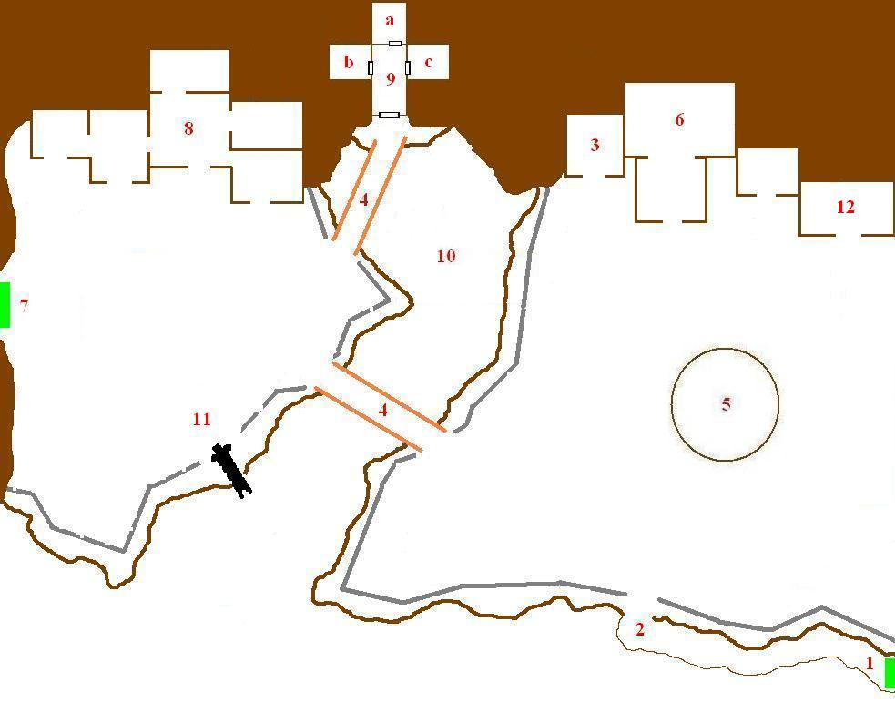
- Entrance/Exit: This is a narrow path leading down the canyon floor.
- Village Ladder: This 40' tall ladder is wide enough for two people to climb side by side. It's the only way to reach the village courtyard.
- Food Preparation Area: Vegetables and game meat are cut and dried here, or cooked into stew. The Ciphers are very watchful over the food supply since the village must ration its food.
- Suspension Bridge: A rope and wood suspension bridge spanning the chasm.
- Kiva: Pronounced "kee-vah". A ladder leads 20' down into this 40' wide covered pit (there is a hole in center of the cloth covering, though). The sides of the pit are painted and carved with mathematical formulas and electronic schematics explaining how to build a variety of electronic devices. Many of the paintings and carvings have faded due to age. The Nemonik and his assistants are found here most of the time, studying the schematics.
- Trig's Workshop: Scattered all the tables in this building are numerous bits of tech scavenged from the wasteland, along with mechanic's tools. It functions as a Mechanic's Lab.
- Trail to the Mesa Top: This trail follows the side of the cliff up to the mesa top.
- Residences: All of the rooms are linked, but curtains of beads and cloths separate each individual room. There isn't much privacy in Mesa Verde.
- Storage Cave: Deep in the cliff side is a natural cave which the original settlers enlarged into three separate chambers. Here, they stored the uranium, the computer, and excess weapons.
  - Uranium Storage: Several lead boxes containing about 20 pounds of weapons-grade uranium are in this room. The room hasn't been opened in over a century, and the door is both locked and trapped with a very loud alarm. The alarm will go off once the door is opened.
  - Computer Room: A Vault-Tec computer with a broken power supply.
  - Armory: An armory used to store weapons. There are several guns stored here because the village lacked the ammo to use them.
- Canyon Floor: This isn't accessible to the player, but when he's standing at the edge of the village, he can see hundreds of feet down into the valley floor.
- Laser Cannon: A big laser death cannon, pointed right at the Viper camp on the canyon floor. Unfortunately, the cannon doesn't work. If the PC gets it working, the cannon can only fire once before it self-destructs due to its makeshift construction.
- Isaac's Dwelling: The ex-BoS Scribe Isaac makes his home here. During the day, he can be found in Trig's workshop, assisting her.
- Azkee's Dwelling: This is the traditional dwelling of the Counter, Azkee in this case. He's got nicer stuff than most of the other villagers
- Hospital: A crude hospital. A sick Cipher child and woman lie here. They have the worst cases of radiation sickness in the village.

SCRIPTING

- Player enters the map for the first time:
  - Player is hailed by a Cipher sentry and questions are asked. If the player isn't a total jerk, he's allowed into the village.
  - If the PC is dressed like a Viper or a Daughter of Hecate, the sentry will freak and sound the alarm, but the PC will have a chance to explain things.
- Player enters the map subsequent times:
  - If the player got booted from the village because he got caught stealing, the sentry confronts him. PC will need a good Persuasion to be allowed back into the village.
  - If the wind turbine is broken, or the food was poisoned, the PC is not allowed back into the village because everyone is certain he's to blame. PC will need to be persuasive to be allowed back in. This does NOT happen if the PC gets Radian to do those deeds.
  - If the PC is dressed like a Viper or a Daughter of Hecate, the sentry will freak and sound the alarm, but the PC will have a chance to explain things.
- Player enters the map with a bunch of Vipers with him.
  - Instant combat. The sentries shout the alarm and attempt to block the entrance to the village. After a few rounds, the villagers at the mesa to spawn in at the east and rush to join the battle.
- Player fires the Laser Cannon:
  - This causes most of the Vipers at the camp on the Canyon map to be fried and dead the next time the player goes there. Drake and a handful of other Vipers (3-4) will still be alive and very, very angry.
- Poisoned food supply:
  - If the food supply is poisoned, the next day many of the Ciphers will be dead or dying in a group around the hospital.
- Attacking a villager:
  - Sentries sound the alarm, and the rest of the village gangs up on the PC.
- Getting caught stealing:
  - Shouts of "Thief!" will draw Azkee and a group of villagers to the PC, and they'll firmly ask him to hand back what he stole and then leave the village.
- Village Prosperity:
  - If the PC hasn't done anything to help the Ciphers get food and the Vipers are still around, they'll float stuff about being hungry.
  - If the PC has cleared the canyon caves and food is getting smuggled in, the floats will reflect that.
  - If the molerat caves are restocked, the Ciphers will mention it.
  - If the crops are known to be contaminated, the Ciphers will complain, UNLESS the PC has taught them how to hunt better, in which case they'll wish for something other than meat for a change.
  - If the PC brings them a GECK, everyone will be happy.

Mesa Top
A small abode pueblo built along the underside of an overhanging cliff. A chasm splits the village in two, requiring the Ciphers to use rope suspension bridges to span the gap. The two most apparent features of the village are a large covered pit near the village entrance and a partially complete laser cannon aimed at the Viper camp down on the canyon floor.

Mesa Top Map
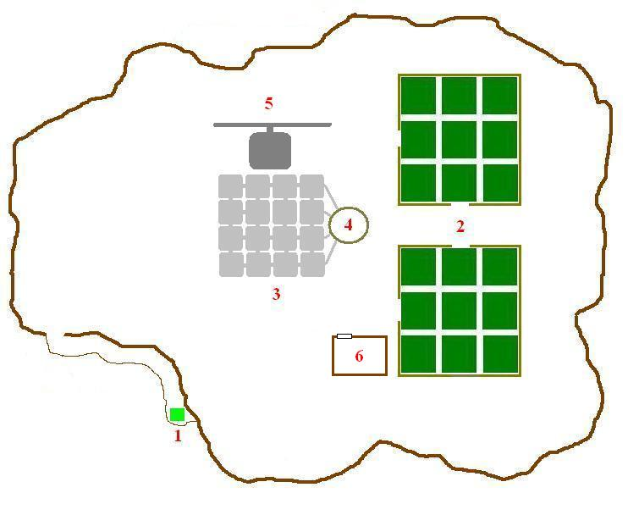
- Trail to Village: This trail winds around the side of the mesa to the village. Full-party transition.
- Greenhouses: Lacking access to glass, the Ciphers draped clear plastic over simple wooden frames to create a pair of greenhouses. Crops like soybeans, squash, cabbage, and carrots are grown in shallow hydroponic bays.
- Water Maker Array: Sixteen electric water makers condense moisture from the air into drinking water. They're powered by the nearby wind turbine.
- Small Covered Vat: The water makers don't produce very much water, barely filling this small covered vat each day. The Counter maintains strict water discipline. There needs to be enough water left over for the crops, so each villager is only gets a set amount of water.
- Wind Turbine: A tall wind turbine. Its triple-bladed propeller rotates steadily in the constant breeze atop the mesa. It generates electricity for the water makers.
- Storage Shed: A plain wooden storage shed with a locked door. It holds gardening tools and an empty barrel which once contained radioactive fertilizer.

SCRIPTING

- Player enters the map for the first time:
- When the player gets the center of the map, he'll see all the Ciphers ganging up on a group of weedlings which spawned in one of the greenhouses. After the weedlings have been defeated, the Ciphers will resume work in the greenhouses.

Canyon
Rocky canyons surrounding the base of the mesa. At a junction of several canyons, including the one which leads to the village, is a Viper encampment. They stop anyone who's trying to go to or come from the Cipher village.

Canyon Map
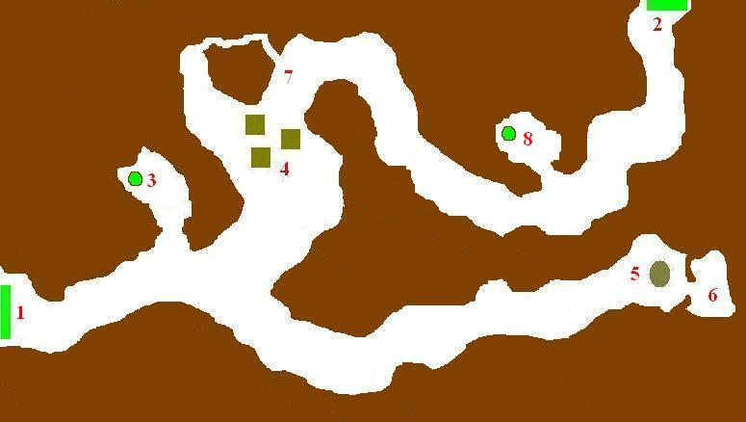

- Transition to World Map: The exit to the world map. Full-party transition.
- Trail to Village: A trail follows the side of the mesa up to the village. Full-party transition.
- Canyon Cave: A narrow hole in this cave descends into underground caverns.
- Viper Camp: A band of badass Viper Raiders are camped here, stopping anyone from coming and going to the village.
- Alexandra's Camp: Alexandra has set a small camp behind a 3-foot high wall of rocks. She caught sight of Blackjack several days ago and chased him here. Blackjack is worthless to her dead, but she doesn't have the faintest idea how to get him out of the cave without facing his minigun. She's hoping she can starve him out, but with his super mutant endurance, that doesn't seem too likely.
- Blackjack's Cave: Blackjack the super mutant, one of the escaped prisoners from the Big Empty, has barricaded himself inside this cave. He had been running from Alexandra, who'd been on his trail for days, and he didn't realize the canyon didn't go any further. He claims to have a minigun (actually just a bundle of sticks and pipes painted black with charcoal), and hopes Alexandra will eventually give up and go away.
- Unstable Cliff: The entire side of this cliff is extremely unstable. An explosive could bring the whole thing crashing down.
- Other Canyon Cave: The narrow hole in this cave descends into underground caverns.

Caves
These short series of caves runs underneath the Mesa Verde canyon. They were once home to a rather hefty population of molerats, but that population has since been decimated by the Vipers' pet two-headed rattlesnakes. The player can use these caves to bypass the Viper blockade, but he'll probably have to deal with the snakes.

Caves Map
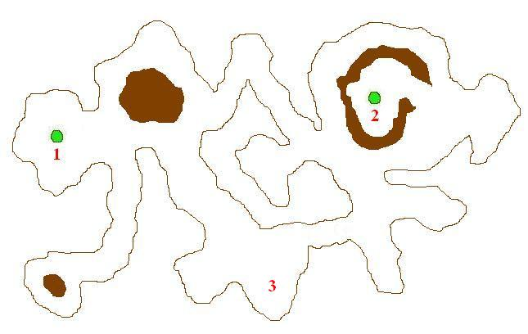

- Hole: A hole leading upward to the canyon above.
- Hole: Another hole leading to the canyon above. The ground around this hole looks heavily traveled by both molerats and humans.
- Molerat Nest: This used to be the main molerat nest until they got eaten by the rattlesnakes. There are a lot of shiny baubles and junk scattered throughout the nest.

ART REQUIREMENTS

Canyon
Mesa tileset. Need props for the Viper camp. Also will need a big pile of rubble to simulate a destroyed cliff which will appear on top of the Viper camp if the player successfully demolishes the nearby cliff.

Caves
Cave tileset. Need props for a messy-looking molerat nest.

Village
Pueblo tileset for the dwellings, mesa tileset for the environment. Tribal propset mostly, with a few techy-looking items: a mechanics' workbench covered with wires and parts, and a big metal footlocker for Isaac's quarters. The kiva (a big pit) needs a cloth covering across the top, and the walls are covered with carvings and paintings of electronic schematics.

Mesa Top
Mesa tileset for the environment. Need meta-tiles for the wind turbine and the water maker array (or just one big meta-tile). The wind turbine should be a cross between a low-tech windmill and one of those sleek turbines you see out in the desert – it should look like something the villagers cobbled together using whatever they found lying around. The roofs of the greenhouses are made of plastic, but that may just require a different texture. Crop tiles, and gardening-type tools to use as props in the toolshed.

CAST OF CHARACTERS

NPCs

Azkee (AZ-kee)
ST 4 PE 6 EN 5 CH 6 IN 7 AG 5 LU 5
Intermediate character. Male human. Middle-aged. The Counter, the leader of the Ciphers. Shaved head, wears an old pocket calculator around his neck as the symbol of his office. He's progressive, and would like to see the Ciphers start using more and more technology to improve their lot in life. He's willing to ally the Ciphers with a technological powerhouse like the Brotherhood, regardless of the consequences.

Morning: Wanders around the village area, checking up on people.

Afternoon: Wandering around the mesa top, checking up on people.

Evening: Back in the village itself.

Night: Asleep in his dwelling.

The Nemonik (Nee-MON-ik)
ST 3 PE 6 EN 4 CH 6 IN 8 AG 4 LU 5
Intermediate character. Male human. Old guy who looks a little like Obi-Wan (the old version). The "memory keeper" for the Ciphers. He's a conservative, believing that the Ciphers will come out much better in the long run by limiting their use of technology. He's worried that Azkee will bring trouble to Mesa Verde. He also believes that encouraging Trig's inventions is the wrong path for her to take, and won't be very happy if the PC helps complete her death cannon.

Morning: In the kiva, teaching the village children mathematics and showing them how to build electronics.

Afternoon: In the hospital, doing his best to attend to the sick people.

Evening: Back in the kiva, studying the schematics.

Night: Asleep in his dwelling.

Trig
ST 5 PE 7 EN 5 CH 5 IN 7 AG 6 LU 5
Intermediate character. Female human in her late 20s. Skilled and smart, but tends to overestimate her own abilities. Can build a lot of electronics. She sings the schematics aloud as she works: "ahr 1, 3 vee resistor, wire sequence 1 dash 29, 3 dash 103 dash 109, ahr 2, 1 point 5 vee resistor...". Trig is a store where the player can buy electronic goodies like infrared goggles and Geiger counters.

Morning to Evening: In her workshop, working on stuff.

Night: Asleep in one of the dwellings.

Denom (DEE-nom)
ST 6 PE 5 EN 6 CH 5 IN 5 AG 5 LU 4
Intermediate character. Male human. Has been walking around lately looking quite pleased with himself thanks to the mysterious prosperity of the crops. The mechanic/gardener responsible for maintaining the wind turbine, water makers, and greenhouses.

Morning to Evening: Up at the mesa top, wandering between the turbine and the greenhouses.

Night: Asleep in one of the dwellings.

Blackjack
Major character? Male super mutant. Prisoner #21. Normally very easy-going and friendly. He's currently barricaded inside a cave down in the canyon, cornered by Alexandra. She won't go in after him because Blackjack claims he has a minigun: "Of COURSE I have a minigun! I'm a super mutant. We always carry big, powerful weapons. So, uh, don't come any closer!" His "minigun" is actually just a bunch of big sticks and pipes tied together in a bundle and smeared with charcoal to dye them black. He's also got a big pack of supplies, so he'll be able to hang out in the cave for quite some time.

Morning to Afternoon: Helping Trig out in her workshop.

If the PC helps him escape from Alexandra, he'll disappear from Mesa Verde and reappear at the casino in Hoover Dam. If Alexandra captures him, he'll disappear from Mesa Verde and reappear as a prisoner of Caesar's Legion at Denver.

Isaac
ST 4 PE 7 EN 6 CH 7 IN 8 AG 6 LU 5
Major character. Male human in his 50s. Former BoS Scribe. He humbly serves as Trig's assistant and keeps a low profile. He stand outs because he doesn't have the body paint like a normal Cipher. He's got his old set of power armor stashed in his dwelling, which he might be willing to give to a player who does a lot of good things for the Ciphers.

Isaac can give the PC a great deal of information about the Brotherhood. The player will need to be on Isaac's good side if he wants to find out the location of Maxson's Bunker from him. Isaac's goodwill may also be necessary if the player wants to get all the runaway Scribes to return to the bunker.

Isaac can also offer upgrades to high technology equipment, or even build it for the player, if the player brings him the parts. He wasn't an Elder Scribe for nothing.

Morning to Afternoon: Helping Trig out in her workshop.

Evening: Hanging around the wind turbine, enjoying the view.

Night: Asleep in one of the dwellings.

Vipers (20)
ST 6 PE 6 EN 6 CH 3 IN 5 AG 6 LU 5
Minor characters. Male humans. Part of Hecate's personal army. They're armed with melee weapons only.

Morning to Evening: Most of them will be hanging around the camp, with a few on the outskirts acting as sentries. A few will be asleep in the camp.

Night: Many of the Vipers will be asleep, while the guys who were asleep during the day will be awake and acting as sentries now.

Drake
ST 7 PE 6 EN 7 CH 5 IN 5 AG 6 LU 5
Intermediate character. Male human. Tall, muscular guy who looks like a heavily-tattooed Vin Diesel. Leader of the Viper band at Mesa Verde. He's not particularly evil, but his unshakeable loyalty to Hecate and the Daughters often requires him to perform cruel deeds. Carries a large machete.

Cipher Adults (18)
ST 5 PE 6 EN 5 CH 4 IN 6 AG 5 LU 5
Minor characters. Male and female humans. These generic villagers will be in two places during the day. A small group (3-4) will be in the kitchen. There will be a group on watch (4), and the rest of them will be up at the mesa top working in the greenhouses. Lightly armed with spears, knives, and the occasional zip gun.

Morning to Evening: Greenhouse workers will be up at the mesa top, diligently taking care of the crops. Kitchen workers will be making soybean paste and other stuff in the kitchen.

Night: Asleep in one of the dwellings.

Cipher Children (7)
ST 3 PE 6 EN 4 CH 5 IN 5 AG 6 LU 5
Minor characters. Male and female human children.

Morning: Sitting around in the kiva listening to the Nemonik lecture.

Afternoon: Running around the village playing.

Evening: Sitting around the kitchen.

Night: Asleep in the dwellings.

Hex
ST 5 PE 6 EN 5 CH 4 IN 6 AG 5 LU 5
Intermediate character. He's the Cipher who seems to be perpetually on duty whenever the PC enters the village. Armed with a pipe rifle and a knife.

Radian
ST 5 PE 5 EN 4 CH 3 IN 5 AG (2)5 LU 5
Intermediate character. Male human. A Cipher suffering from a nervous disorder. Shakes a lot, especially in his hands. The PC can use medicine to cure him or make him a slave to the PC's will. If he becomes the PC's puppet, he'll eventually get banished from Mesa Verde and appear in the slums of Hoover Dam.

Morning to Evening: Up at the greenhouses, "helping". His float texts will be lots of curses at his clumsiness, but this will change if the PC cures him. If the PC makes him an addict, his floats will reflect that as well.

Night: Asleep in the dwellings.

Symm
Intermediate character. Male human. This guy shows up in Act 2, after the PC realizes he needs a docking clamp. If the Ciphers are still alive, then he'll be up near the condensors (Trig will direct the PC to him). If the Ciphers are dead, he'll be in the main part of the village, pissed and looking for revenge.

COMPANIONS!

Alexandra
ST 5 PE 6 EN 6 CH 4 IN 6 AG 6 LU 5
Female human. Potential CNPC. Not a Cipher, just a visitor to Mesa Verde. She's a bounty hunter and she's trying to take Blackjack alive. Caesar's Legion is paying well for live super mutants, and she means to score big with this particular bounty. However, Blackjack is barricaded in a cave with a minigun (or so he claims), so Alexandra is trying to starve him out. If the player manages to get Blackjack to go back to the Big Empty, he'll still have to deal with Alexandra. He can compensate her with money, or promise bigger money if she tags along as a CNPC.

MONSTER ROSTER

Weedlings (8)
Plant monsters who spawned as a result of the radioactive waste used to fertilize the crops. When the PC encounters them, they'll be in battle with a group of Ciphers in one of their greenhouses.
They will be in battle with the Ciphers when the player first encounters them.

Two-headed Rattlesnakes (6)
Giant two-headed rattlesnakes. They're the pets of the Vipers camped in the canyon. The Vipers give the snakes freedom to roam, and the snakes are usually found in the underground caverns hunting molerats.
The snakes will be randomly roaming the Mesa Verde caves. If they encounter a molerat, they'll attack it.

Molerats (3)
Molerats running around in a series of caves in the canyon. The Ciphers hunt these guys for meat, but now the rattlesnakes are hunting them as well. These three guys are the sole survivors.
The molerats are not particularly aggressive and will only attack if the PC walks right next to them. Otherwise they'll do their best to run away from both the PC and the snakes.

Geckos (~7)
A few geckos wander around in the canyon area. They avoid the Viper camp.
Their wander routes will be confined to the canyons, and they won't go near the Viper camp or Alexandra's camp.

RANDOM ENCOUNTERS SURROUNDING THE AREA

Cipher Nomads (8-12)
A band of Ciphers either on their way out or heading in to Mesa Verde. Usually 75% of them will be adults, with the remainder being teens or younger. Happens three times.

Viper Patrol (5-6)
A patrol of Vipers scouting the area around Mesa Verde. They'll be wary of the PC, unless he's got a Cipher texture, in which case they'll attack. These encounters will stop if the main Viper camp is destroyed. Happens five times.

Desert Stalkers vs Ciphers
A small band of Ciphers battling several desert stalker they encounter. Happens once.

Vipers vs. Ciphers
A skirmish between a Viper patrol and a band of Ciphers. Happens twice.

Wolves and Corpses
The aftermath of a Viper/Cipher battle. There are several corpses being chewed on by ravenous wolves. Happens four times.

Radscorpion Pack
The PC inadvertently wanders into pack of hidden radscorpions who buried themselves to hide away from the desert sun. Daytime encounter.

Hunting Radscorpions
The PC runs into a pack of hungry, hunting radscorpions during a night trek. Night encounter.

QUESTS

- Deal with the Vipers.
A month ago, as punishment for defying her, Hecate sent a band of Vipers to lay siege to the village of Mesa Verde. There's only a handful of healthy Cipher warriors in the village, but they're in an extremely defensible position. Unfortunately, there are not enough of them to take to the fight to the Vipers. At the same time, the Vipers are unable to breach the village's narrow entrance, so they're biding their time, letting hunger weaken the Ciphers before the next assault begins.

Initiator: Azkee
Scope: Small
Importance: Minor
Science Boy: Help the Ciphers finish constructing their Laser Cannon. Construction of the Cannon began several weeks ago to boost the village's defenses, but the project was abandoned when Trig couldn't get it to work. She thought she could just use the Laser Pistol schematic and build a giant version, but it's not working as she hoped it would. If the PC could complete it and get it working, it will be a very useful weapon to use on the Vipers (Science, Mechanics/Average). However, Trig doesn't have the parts necessary to make the Cannon work, so the player will need to explore elsewhere in the wasteland to find them. A Doctor can create drugs to buff up the Cipher warriors and give them an edge over the Vipers, as well as supply them with stimpaks (Medic/Average).
Stealth Boy: Sneak into the Viper camp (Sneak/Average) and poison their food and water. It won't kill all of them, but the survivors will be weak and easy pickings for the Cipher warriors. If the player steals some of the supplies instead (Steal/Average), he'll get props from the Ciphers (and an xp bonus). Or, rig explosives (Traps/Average or Traps/Easy + High Luck) on the nearby unstable cliff so that when the cliff collapses it lands right on the Viper camp and crushes most of them.
Combat Boy: Eliminate the Vipers with brute force. This will be a fairly tough fight, since the Vipers aren't your usual band of Raiders. They're skilled fighters, they fight with fanatical determination, and there are almost two dozen of them.
Charisma Boy: A female PC can dress up like a Daughter of Hecate and deceive the Vipers, ordering them to leave the Ciphers alone (Deception/Easy). Likewise, a male PC can disguise himself as a Viper and pass himself off as a survivor from another group (Deception/Hard). He can then claim the Vipers have been ordered to withdraw from Mesa Verde. A persuasive, combat-oriented PC can ask Azkee to send some of his best Cipher warriors to help the PC kill the Vipers (Persuasion/Average).
Reward: XP, loot from the any Vipers you killed.
Journal Entry:
- Azkee asked me to remove the Vipers harassing his people.
- I finished construction on Trig's Laser Cannon and fired it at the Vipers. The results were... impressive.
- I slipped into the Viper camp undetected and poisoned their food and water supply. (I had the foresight to swipe some of their supplies for the Ciphers).
- The Vipers never had a chance when the explosion went off and the cliff came down. Most of them lie buried beneath a ton of rock now.
- I attacked the Viper camp head on and was victorious.
- I posed as a Daughter of Hecate and tricked the Vipers into leaving Mesa Verde. / I posed as a Viper and tricked the Vipers into leaving Mesa Verde.
Dumb Journal Entry:
- Painted guy say make snake men go away.
- Big light work now. Went zap! zap! zap! Lotsa crispy snake men.
- I put bad stuff in snake men's food. (I also take food for painted people.)
- I make big boom. Rock fall on snake men. All dead now.
- Killed all the snake men.

CIPHER_CANNON = 0 // Player hasn't inspected the Cannon
CIPHER_CANNON = 1 // Player has inspected the Cannon
CIPHER_CANNON = 2 // Player has spoken to Trig about the Cannon
CIPHER_CANNON = 3 // Player finished the construction of the Cannon

VIPER_SIEGE = 0 // Vipers are still around
VIPER_SIEGE = 1 // Vipers got blasted by the Laser Cannon
VIPER_SIEGE = 2 // Vipers got poisoned
VIPER_SIEGE = 3 // Vipers got crushed by the cliff
VIPER_SIEGE = 4 // Vipers got killed in combat
VIPER_SIEGE = 5 // Vipers were tricked/intimidated into leaving

- Acquire the Ciphers' enriched uranium.
Some factions in the wasteland (like the ghouls at the Reservation or the Brotherhood) would love to get their hands on some weapons-grade uranium. The player can find out what the Ciphers have by speaking with the Nemonik and deducing that his ancestors were carrying uranium around, fixing the computer and accessing the old records, or by being thiefy and snooping around the uranium chamber.

Initiator:
Scope: Small
Importance: Minor
Science Boy:
Stealth Boy: Steal the box of enriched uranium from the storage cave. A skilled thief would have to disarm the alarm on the uranium chamber door (Traps/Hard) and pick the lock on the door (Lockpick/Hard) or use the key he stole from the Nemonik (Steal/Hard).
Combat Boy: Butcher any Cipher who gets in your way and just take the uranium.
Charisma Boy: Purchase the uranium from the Ciphers (Barter). The Ciphers have no use for the uranium, but because it is within the cave, they know that it is valuable. The price for the uranium will be adjusted depending on how much the PC has helped the Ciphers out in the past, but they won't give it away for free for any reason.
Reward: Small amount of XP and the uranium itself.
Journal Entry:
- I managed to steal the uranium without getting caught.
- The Ciphers tried to stop me from taking their uranium, forcing me to kill them.
- I managed to bargain with Azkee to buy the uranium.
Dumb Journal Entry:
- Stole glowing rocks. Nobody saw.
- Took glowing rocks, painted people not like. Had to kill.
- Gave Azkee stuff. Got glowing rocks.

PENDING...

- Convince Isaac to tell you what the power armor security codes are
Before Isaac left Maxson Bunker, he locked down all the unused suits of power armor with a security code. Naturally, the remaining Brothers aren't too happy about that. The PC's mission is to convince Isaac to reveal what the codes are.

Initiator: (some Brotherhood person)
Scope: Large (need to visit several places in the wasteland)
Importance: Minor
Science Boy:
Stealth Boy:
Combat Boy:
Charisma Boy: Persuade Isaac to tell you what the codes are (Persuasion/Very Hard).
Reward: Moderate XP.
Journal Entry:
- I told Isaac about the situation in Maxson Bunker. It took convincing, but he finally gave me the security codes.
Dumb Journal Entry:

- Ask the Ciphers to process Zax's raw data.
Zax the Supercomputer is having difficulty calculating the spread of the plague because he's old and a lot of his processing power is gone. The PC can help him out by bringing the data to the Ciphers, one of the few places in the wasteland that has any hope of processing the complex information.

Initiator: Zax
Scope: Medium
Importance: Minor
Science Boy: It's a fetch quest, so all the PC needs to do is bring the equation to the Ciphers.
Stealth Boy: See Science Boy.
Combat Boy: See Science Boy.
Charisma Boy: See Science Boy.
Reward: XP, access to Zax's locked-down database(?)
Journal Entry:

ZAX_EQUATION = 0 // PC doesn't have Zax's equation
ZAX_EQUATION = 1 // PC has Zax's equation, and it's not solved
ZAX_EQUATION = 2 // PC gave the Ciphers Zax's equation, and they solved it
ZAX_EQUATION = 3 // PC returned to Zax with the solved equation; Quest Complete

- Sabotage the wind turbine for the Vipers.
Without the turbine powering the water condensors, the Ciphers will weaken enough for the Vipers to overwhelm their defenses.

Initiator: Drake
Scope: Small
Importance: Minor
Science Boy: Sabotage wind turbine and sabotage it (Mechanics/Average). If he's not stealthy about it, though, the Ciphers will attack him. Alternately, if Radian is an addict, the PC can force him to do the deed without drawing attention to the PC.
Stealth Boy: PC will need to be sneaky if he doesn't want to be seen fiddling with the turbine (Sneak/Average).
Combat Boy:
Charisma Boy:
Reward:

- Forge an alliance between the BoS and the Ciphers.
The Ciphers' knowledge of math and electronics makes them ideal replacements for the missing BoS Scribes. The BoS could send some troops to reinforce the defenses at Mesa Verde while the Ciphers can use their wizardry to repair the BoS's equipment. If the player has met both groups, he can suggest an alliance to the leaders. The good thing about the deal is that the Brotherhood won't have to deal with disgruntled Scribes; the bad thing is that all the repair work needs to be outsourced to the Ciphers and won't be done in-house.

Initiator: PC
Scope: Medium
Importance: Minor
Science Boy: Bring a broken Brotherhood item to Trig for repair. Her success will prove that the Ciphers have what it takes to maintain Brotherhood equipment.
Stealth Boy: Same as Science Boy.
Combat Boy: Same as Science Boy.
Charisma Boy: Tell the Brotherhood that you're not a Fed-Ex guy and have THEM go drop off the item (Persuasion/Average).
Reward: XP, access to Brotherhood goodies
Journal Entry: After seeing that the Ciphers were indeed capable of repairing Brotherhood equipment, an alliance was formed between them.
Dumb Journal Entry: Painted people and brothers friends now.

- Repair the computer so the all the Ciphers can access the old knowledge.
Long ago, a Nemonik removed the memory core of the computer so any technical knowledge had to be passed on by the Nemonik himself. This was done to ensure that Mesa Verde didn't destroy itself with technology it wasn't responsible enough to handle. Azkee wants the PC to fix the computer so the Ciphers have access to all the knowledge.

Initiator: Azkee
Scope: Medium (the player will need to find a computer power supply if he's not already carrying one)
Importance: Minor
Science Boy: Buy a replacement memory core and install it in the computer. (Mechanics/Average).
Stealth Boy: "Borrow" a power supply from a junk dealer or salvager somewhere in the wasteland (Steal/varies).
Combat Boy: Kill someone who has a computer core (most likely a salvager or merchant)
Charisma Boy:
Reward: Caps

- Cure Radian.
Radian is suffering from High Desert Fever. A doctor PC can either cure him, or get him addicted to painkillers and turn him into a PC slave.

Initiator: PC
Scope: Small
Importance: Minor
Science Boy: Use your Medic skill to diagnose what Radian has (Medic/Average) and then, using a Doctor's Bag, either cure him or turn him into an addict.
Stealth Boy:
Combat Boy:
Charisma Boy
Reward: Moderate XP and good Cipher rep boost for a permanent cure; less XP for a temporary cure, but the ability to use Radian as a pawn

- Figure out what Denom did to the crops
Azkee is worried about the crops. They're unnaturally large, and he's concerned that Denom might have done something to "improve" the fields which might ultimately prove detrimental to the Ciphers.

Initiator: Azkee
Scope: Small-Medium
Importance: Minor
Science Boy: Use a Geiger Counter on the container of special fertilizer and determine that it's got a moderate amount of radioactive residue in it.
Stealth Boy: Break into the storage shed by picking the lock (Lockpick/Average) or by stealing the key from Denom (Steal/Average). Discover the empty barrel of fertilizer with the glowing residue. If you know the soil is radioactive, you can confront Denom with this evidence.
Combat Boy:
Charisma Boy: If the player is skilled in both deception and persuasion/intimidation (Persuasion/Average, Deception/Average) he will be able to tell that Denom is withholding information about the situation and get a confession out of him.
Reward: Small XP for discovering the source of the sickness; moderate XP if you discover both the source and the person responsible
Journal Entry:
- I discovered that the soil in the greenhouses has become radioactive somehow.
- I found an empty barrel of contaminated fertilizer in a shed near the greenhouse.
- I found out that Denom bought the contaminated fertilizer from a passing trader. The man told him that it would make his crops grow fast and become large.
Dumb Journal Entry:
- Bad dirt in food house.
- I find funny dirt in can in shed.
- Denom say he put funny dirt in food house. He make soil bad.

- Get more food to the Ciphers.
When Denom's irradiation of the crop fields is discovered, the Ciphers will refuse to eat any more of the tainted fruits and vegetables. Azkee will ask the PC to go to Hoover Dam and negotiate with one of the caravans there to have food shipped to the village.

Initiator: Azkee
Scope: Medium
Importance: Minor
Science Boy: Bring the Ciphers a GECK from the Nursery.
Stealth Boy: Bring the Ciphers a GECK from the Nursery.
Combat Boy: Bring the Ciphers a GECK from the Nursery.
Charisma Boy: Travel to Hoover Dam and negotiate the shipment of food to Mesa Verde with one of the caravans (Barter). Otherwise, if an alliance forms between the Brotherhood and the Ciphers, and the Circle of Steel is not in charge, the Brotherhood will share their supplies with the Ciphers. Or, just bring the Ciphers a GECK from the Nursery.
Reward: Cipher rep boost; HUGE Cipher rep boost if you bring them a GECK.
Journal Entry:
- I brought the Ciphers a GECK from the Nursery. It should restore their greenhouses in no time.
- I arranged to have food shipments sent from Hoover Dam. It should keep the Ciphers fed until they can replant their crops.
- The Brotherhood has agreed to share their supplies as part of their alliance with the Ciphers.
Dumb Journal Entry:
- I bring metal case from plant place to painted people. It s'posed to fix crops.
- Big dam people send food to painted people.
- The Brothers give food to painted people.

CIPHER_FOOD = 0 // The Ciphers are not getting outside food
CIPHER_FOOD = 1 // The PC has negotiated food shipments with one of the Hoover Dam caravans
CIPHER_FOOD = 2 // The Ciphers are getting food from their Brotherhood allies
CIPHER_FOOD = 3 // The PC brought the Ciphers a GECK

- Restore the crop fields with the Miracle Wheat.
If the PC learns about the miracle wheat which cleans up irradiated ground, he can mention this to Denom and offer to bring him some seeds.

Initiator: PC
Scope: Medium
Importance: Minor
Science Boy:
Stealth Boy: Steal a bag of the seeds (Steal/Hard).
Combat Boy: Kill the FoA dudes and take the seeds from them
Charisma Boy: Purchase a bag of seeds off the FoA dudes (Barter/Hard).
Reward:

- Rescue the captured Ciphers.
This quest will become available if the Vipers have been dealt with and a caravan is delivering food to the Ciphers. Because the caravans cannot make it up the narrow trail to the village, the Ciphers need to come down into the canyon. A group of slavers, having heard about the developments at Mesa Verde, decided to pose as a caravan and get some Cipher slaves. The ruse worked, and several Ciphers, children included, have been captured. When the player returns to Mesa Verde, Azkee will greet the player at the entrance and tell him what happened. The slavers headed northeast, towards the Caesar's Legion group at Denver.

Initiator: Azkee
Scope: Medium (slavers have left Mesa Verde and need to be tracked down)
Importance: Minor
Science Boy: Using your tracking skills, examine the slaver camp for clues: "The tracks veer to the northeast, and have a great deal of dogshit mixed in them. The Ciphers didn't say anything about them having dogs, so wherever these guys are from, there must be a LOT of dogs (assuming the PC has never been to Denver)." (Outdoorsman/Average) The Ciphers aren't aware of such a place, but Isaac will tell the PC that Denver is notorious for its canine population.
Stealth Boy:
Combat Boy:
Charisma Boy:
Reward: Varying XP, depending on how many Ciphers you bring back alive.
Journal Entry:
- I discovered footprints with traces of dogshit in them heading northeast.
- I learned that Denver has a high dog population. It's likely that the slavers are from there, and are heading back that way.
Dumb Journal Entry:
- I find feetprints with dog poop. They go northeast.
- Lots of dogs in Denver. Slavers go there?

CIPHER_RESCUE = 0 // Cipher kidnapping hasn't happened
CIPHER_RESCUE = 1 // Cipher kidnapping has happened, player hasn't heard about it
CIPHER_RESCUE = 2 // Player has heard about the kidnapped Cipers, hasn't decided on the quest
CIPHER_RESCUE = 3 // Player has heard about the kidnapped Ciphers, has decided to take the quest
CIPHER_RESCUE = 4 // All kidnapped Ciphers have been rescued
CIPHER_RESCUE = 5 // At least one, but less than half, the Ciphers died in the rescue
CIPHER_RESCUE = 6 // More than half, but not all, the Ciphers died in the rescue
CIPHER_RESCUE = 7 // All the Ciphers died in the rescue
CIPHER_RESCUE = 8 // Player has heard about the kidnapped Ciphers, has refused the quest

- Bring a GECK to Isaac in exchange for his power armor.
Isaac wants the PC to bring him a GECK to study, and in exchange he'll give the PC his old power armor. However, no GECKs are available, but the PC can have DIANA give him a holodisk with information about the GECKs which Isaac will accept as a trade.

Initiator: Isaac
Scope: Medium
Importance: Minor
Science Boy:
Stealth Boy: A character with good Sneak and Steal skills (Sneak/Hard, Steal/Hard) can run off with the armor, but he'll need to find a way to crack the security code which has locked down the armor.
Combat Boy:
Charisma Boy: A character with a decent Barter (Barter/Average) will be able to persuade Isaac that everything has a price, and Isaac will suggest trading the armor for a GECK.
Reward: Power Armor!

- Resolve the Alexandra-Blackjack situation.
Blackjack is barricaded, hiding out from Alexandra. He doesn't want to have to kill her, but he doesn't want to shot, either (he's unaware that Alexandra needs him alive). If the player gets Alexandra off Blackjack's back, he'll head over to Hoover Dam to go find some card games, and Alexandra, if still alive, will head over to Fort Abandon to hang out. If the PC helps Alexandra capture Blackjack, she'll take him to Denver and give him to the Caesar's Legion slavers before returning to Fort Abandon.

Note: if the PC is aware he needs to bring prisoners back to the Big Empty, he can ask Blackjack about it if he helps him out. Blackjack will want to gamble at Hoover Dam first before returning to the prison (this will lead to the problem of actually tearing him away from the card games: "Just one more hand. I can't quit while I'm winning!"). If the PC hasn't helped Blackjack, or Blackjack is a prisoner in Denver because of the PC, he'll tell the player to fuck off.

Initiator: PC
Scope: Medium
Importance: Major
Science Boy: After speaking to Alexandra, just tell Blackjack that he's worthless to her dead, and he'll make a break for it.
Stealth Boy: After speaking to Alexandra, just tell Blackjack that he's worthless to her dead, and he'll make a break for it.
Combat Boy: Attack Blackjack and take him down using non-lethal methods. If you kill Blackjack, however, you get no reward from Alexandra. You can also knock out or kill Alexandra and help Blackjack escape. He'll be regretful if she's dead, but he won't hold it against you.
Charisma Boy: Offer to compensate Alexandra if she'll let Blackjack go (Barter) or persuade her to tag along with you by promising bigger rewards in the future (Persuasion/Average). You can't persuade Blackjack to give up, but you can trick him into coming out (Deception/Average) if you're helping Alexandra.
Reward: Money and items if you help Alexandra; share of Blackjack's winnings if you help him go to Hoover Dam.
Journal Entry:
- I met Blackjack, a super mutant and fellow ex-prisoner. He was cornered in a cave, and he asked me to help him escape from the bounty hunter who'd been chasing him.
- I met a bounty hunter named Alexandra. She had trapped a super mutant in a cave, and offered to split the reward for his capture if I helped her out.
- I helped Blackjack escape from the bounty hunter. He thanked me, and told me he would be in Hoover Dam if I ever needed him again.
- I helped Alexandra capture the super mutant. She told me she'd deliver him to her contacts in Denver, and offered to meet me at Fort Abandon to split the reward.
Dumb Journal Entry:
- I meet Blackjack, big mutant prisoner guy. He say help from hunter who chase him.
- I meet blonde girl Alexandra. She chasing big mutant guy. Need help.
- I help Blackjack big mutant guy run away from blonde hunter girl. He say meet him in big dam place where cards and money are if me need help with something.
- I help blonde girl Alexandra catch big mutant guy. She say meet her at Fort A-ban-don? She say she give me stuff for help.

- Kill the weedlings.
When the PC first arrives at the mesa top, Denom and the Ciphers at the mesa top will be battling a group of weedlings in one of the greenhouses. If the PC chooses to help out, he'll get an xp bonus. If he just stands by, the Ciphers are eventually victorious, and the PC gets no xp.

Initiator: PC
Scope: Small
Importance: Minor
Science Boy:
Stealth Boy:
Combat Boy: Help kill the weedlings.
Charisma Boy:
Reward: Small XP, small Cipher rep boost.
Journal Entry: I helped the Ciphers destroy the weedling infestation.
Dumb Journal Entry: I help painted people kill moving plants.

- Build an alarm for Trig.
Trig is attempting to build an electronic alarm for the path leading up to village, something which will alert the Ciphers to visitors. She can't quite get it working, though.

Initiator: PC
Scope: Small
Importance: Minor
Science Boy: Use Mechanics (Mechanics/Easy) to finish the alarm, or show Trig how to make a primitive but equally effective alarm (Outdoorsman/Easy).
Stealth Boy:
Combat Boy:
Charisma Boy:
Reward:

Area | Quest Name | Designer | DStatus | Script | SStatus | Log Stat | Passable | QA 100%
Mesa Verde
Village | Deal with the Vipers.
Village | Acquire the enriched uranium
Village | Bring a GECK to Isaac
Village | Have the Ciphers process Zax's equation
Canyon | Sabotage the wind turbine
Village/Maxson's Bunker | Forge an alliance between BoS and Ciphers
Village | Repair the computer
Village | Cure Radian
Village | Figure out what Denom did to the crops
Village | Get more food to the Ciphers
Village | Restore the crop fields with the Miracle Wheat
Village | Rescue the captured Ciphers
Canyon | Resolve the Alexandra-Blackjack situation
Mesa Top | Kill the weedlings
Village | Build an alarm for Trig.

MERCHANT QUESTS

When the Ciphers discover they no longer have a steady supply of food, the player arrange to have a caravan head their way from time to time.

SCRIPTING

GENERAL

If the PC poisons the Viper food supply, most of them will be dead a day later. The leader and a couple of other guys will survive.

If there is a Brotherhood-Cipher alliance, then a few Brotherhood soldiers will show up and hang around the Cipher village. They're not necessarily Power Armor guys – just regular soldiers.

There will need to be a script where the Viper leader becomes aware that not all is right when the PC kills a certain number of Vipers without being caught.

Once the PC completes the "Restock the Molerat Caves" quest, there should be a bunch of molerats running around in the caves.

TOWN-SPECIFIC

COOL SHIT

COOL EPITHETS

Personal Number
The Nemonik, using some obscure formula and any number of factors, has determined that the number 13 is your personal number - what a coincidence. In any case, you can have your face and body painted accordingly for luck and protection. PC gets a new, Cipher skin-texture for his avatar if he chooses.

COOL HOOKS

New Electronics
If the PC isn't skilled in Mechanics, he can bring Trig uncommon parts he finds in the wasteland to see if she can do anything with it. With the parts (and Isaac's help), Trig can put together some rare stuff which she'll trade to the PC once she's done building it.

Brotherhood Equipment
If an alliance is forged between the Ciphers and Brotherhood, Trig will eventually have a lot of Brotherhood equipment lying around her shop. A larcenous PC could swipe some of the stuff, or a persuasive PC could convince Trig to declare some of the fixed items "irreparable".

TASK LIST

SOUND REQUIREMENTS

AREA | SOUND REQUIREMENTS
Village | MUSIC DESCRIPTION
 | Something reflective the mix of primitive tribal tools with the sophisticated knowledge the tribals have in their heads. Perhaps something like "Metallic Monks" from FO1 with a more tribal beat to it.
 | BASIC SFX
 | Creaking of the rope suspension bridges as they sway in the breeze.
 | WALLA SFX
 | Occasional murmured conversations between small groups of Ciphers. Laughter of children if they're running around playing. (If the food supply has been poisoned, or if it's night, then this walla stops)
Mesa Top | MUSIC DESCRIPTION
 | Something reflective the mix of primitive tribal tools with the sophisticated knowledge the tribals have in their heads. Perhaps something like "Metallic Monks" from FO1 with a more tribal beat to it.
 | BASIC SFX
Tattered plastic from the greenhouses flapping in the occasional breeze.

The steady whoosh-whoosh-whoosh from the propeller of the wind turbine. (This stops if the PC breaks the turbine)

Quiet whirring of the turbine's gears. (Stops if the turbine is broken).

Scrapping and clicking of gardening tools as the Ciphers work the crops. (Stops at night when no one's around)
 | WALLA SFX
 | Ciphers calling to each other as they work the field. They also hum short tunes and bits of songs. (Stops at night, or if the food has been poisoned)
Canyon | MUSIC DESCRIPTION
 | Lonely wilderness music.
 | BASIC SFX
 | Small rocks falling from above, cracking and tumbling down the sides of the cliffs
 | WALLA SFX
 | Chuckling and guffawing when the Viper camp is onscreen. The bits of chatter should sound something like a platoon of roughnecks grumbling and muttering.
Caves | MUSIC DESCRIPTION
 | Gloomy underground music.
 | BASIC SFX
Occasional hissing of a rattlesnake (stops when they're all dead)

The rattling of a rattlesnake tail (stops when they're all dead)
 | WALLA SFX
 | None

LOCATION CHECKLIST

Attribute | Challenge | Reward
CHARACTER SPECIFIC
Evil Karma Character | none | none
Good Karma Character | none | none
Stupid Character | The Vipers, seeing your mental inferiority, will let you pass through their camp | Can just walk through the Viper camp to enter and leave the Cipher village
Low Reputation Character | none | none
High Reputation Character | none | none
Male Character | Pose as a Viper | Fool the Vipers into leaving
Female Character | Pose as a Daughter of Hecate | Fool the Vipers into leaving
Strength | none | none
Perception | Notice that Blackjack's "minigun" is nothing more than a bundle of sticks and pipes  Notice Denom's reaction when you tell him that the greenhouses are contaminated | Call his bluff  Can ask him about his odd reaction
Endurance | none | none
Charisma | Deceive the Vipers by posing as a Daughter of Hecate | A high Charisma female can promise Drake a special "reward" back at Ouroborus
Intelligence | Make the connection between the contaminated greenhouse and the radiation sickness in the Ciphers
Agility | none | none
Luck | Use explosives in an attempt to drop a cliff on the Vipers | If your Traps skill isn't sufficient to "aim" the cliff at the Vipers, a high Luck will miraculously drop the cliff on them anyway
Combat Boy
Firearms | Help or kill the Ciphers | Acquire a crude laser pistol/laser rifle
Melee | Help or kill the Ciphers | Acquire a cattle prod which can be set to various power levels
Unarmed | Help or kill the Ciphers | Acquire the Electro-Gauntlet
Charisma Boy
Barter | Offer to pay Alexandra if she'll give up Blackjack  Offer to buy Blackjack from Alexandra  Negotiate with one of the Hoover Dam caravans to bring food to Mesa Verde  Purchase the uranium from the Ciphers
Deception | Pose as a Daughter of Hecate and trick the Vipers into leaving (female)  Pose as a Viper and trick the Vipers into leaving (male)  Deceive Isaasc by making him believe that the CoS is no longer in charge of the Brotherhood  Recognize that Denom isn't telling you the whole truth | The Vipers leave peacefully.  The Vipers leave peacefully.  Discover that it was he who contaminated the greenhouses.
Persuasion | Intimidate the Vipers into leaving  Persuade/intimidate Denom into confessing once you realize he's not telling you everything  Convince Azkee to let you take some Ciphers along when hunting rattlesnakes  Convince Azkee to let you take some Ciphers for backup when you attack the Vipers | No need for fighting.  Learn how the crop contamination happened; bonus XP for being thorough  Support during the fighting.  Support during the fighting.
Science Boy
Medic | Diagnose Radian's nerve condition  Concoct a permanent cure for Radian  Concoct a temporary cure for Radian  Diagnose the radiation sickness in the Ciphers  Teach a refresher course in medicine to the Nemonik and his assistants | XP, and the knowledge to formulate a cure  XP and a Cipher rep boost  Can force Radian to do your bidding to complete other quests  XP, and a clue to the source of the problem  XP based on your skill level
Mechanics | Complete the construction of the Laser Cannon  Repair the computer  Sabotage the wind turbine so that the Ciphers go thirsty | Zap the Vipers from above  Enable the Ciphers to store their schematics electronically  Weaken the Ciphers with thirst and enable the Vipers to conquer them
Science | Determine that the radiation poisoning is coming from the fruits and vegetables at the greenhouses  Develop a molerat pheromone to attract molerats to traps | Alert Azkee and the Ciphers will stop eating the contaminated food  Bait for characters not skilled in Outdoorsman
Outdoorsman | Track and trap live molerats  Track the slavers who kidnapped the Ciphers  Teach the Ciphers to be more effective hunters | Restock the caves so the Ciphers have a meat supply  Find out where the kidnapped Ciphers are so you can rescue them  XP based on your skill level
Stealth Boy
Lockpick | Pick the lock on the uranium storage door | Access to the uranium.
Sneak | Sneak into the Viper camp to poison their food and water  Sneak into the village | Destroy most of the Vipers without having to fight them  Get in if you pissed off the Ciphers.
Steal | Steal food and water from the Vipers  Steal the storage shed key  Steal the uranium storage key from the Nemonik | Bring back some of the Viper supplies for the hungry Ciphers for bonus XP  Get into the shed and find proof of Denom's goof  Access to the box of uranium.
Traps | Rig the unstable cliff near the Vipers with explosives so that it will crush them when it falls  Build non-lethal molerat traps  Disarm the alarm on the uranium storage door. | Crush most of the Vipers without having to fight them  Trap molerats and restock the caves  Access to the box of uranium.
Generic Skills
Easter Egg, Easy 1
Easter Egg, Medium 1
Easter Egg, Hard 1
PERKS + TRAITS
Perks
Traits
ENVIRONMENT
Economics | Limited trading with passing caravans
Power/Infrastructure | Electricity generated by the wind turbine powers the water makers
Food | Vegetables grown in the crop fields; meat from game animals
Tie to Another Area 1 | Denver | A potential supplier for Trig can be found there, and the slavers take the captured Ciphers there
Tie to Another Area 2 | Hoover Dam | Food shipments from Hoover Dam
Tie to Another Area 3 | Ouroborus | The Ciphers know the location of the Vipers, and they believe Hecate may be there as well.
Tie to Another Area 4
MULTIPLAYER GAMING
Multiplayer Elements?

ROOM FOR IMPROVEMENT

Prosperity: The Ciphers are pretty poor in general. Nobody has more than a few caps on them, and most of their equipment is cheap, primitive stuff. The electronics are the most valuable items in the village, but there's currently only a few of those available.
Quests: None?
Store: Trig – in addition to electronic goodies, she's got things like stimpaks or other basic adventuring supplies acquired from passing traders.
Store Frequency: No restocking occurs while the Vipers are still around. Minimal restocking if the PC clears out the molerat caves (small items get smuggled in). Good restocking every few weeks if the Vipers are gone.
Morale: High morale. The Ciphers will defend their home to the death.
Armament: Mostly melee – spears, knives, and pipes. A few zip guns. Leather armor.
General Health: Poor, and growing worse. Not only have the Ciphers been subsisting on a dwindling supply of fruits and vegetables, but they're becoming more and more radiated from those same vegetables.
Community: Strong defense. There's only one way into the village, and that way lies up a narrow path and long ladder. It's very easy for the Ciphers to repel attacks on the village.
Services: Trig has several electronic items to trade, and her workshop functions as a Mechanics Lab.
Communication: None. No radios.
Technology Level: Low-Medium. The Ciphers have lots of low-tech gear like knives, zip guns, and leather armor, but they also have the occasional tech device, like infrared goggles.

END MOVIES

WHERE TO GO CONDITIONS
The player never entered Mesa Verde. | Skip Cinematic
The player didn't deal with the Viper siege. | Goto 1
Alliance with BoS, CoS in charge | Goto 2
Alliance with BoS, CoS not in charge | Goto 3
Ciphers all dead | Goto 4
Mesa Verde got nuked. | Goto 5
Vipers dealt with, Ciphers left alone | Goto 6

1. Vipers not dealt with (WTG)
The Vipers eventually crush the village of Mesa Verde for defying Hecate. The surviving Ciphers are scattered into the wasteland, taking their secrets from the Old World with them. | The village at Mesa Verde in ruins, with corpses lying everywhere and black smoke pouring out of the dwellings.

2. Alliance with BoS, CoS in charge (WTG)
The Circle of Steel's paranoia eventually causes them to withdraw all troops to Maxson's bunker. The NCR, learning of the Ciphers' collaboration with the Brotherhood, launch a massive assault on the village. Every Cipher man, woman, and child dies in the siege. | The village at Mesa Verde in ruins, with corpses lying everywhere and black smoke pouring out of the dwellings.

3. Alliance with BoS, CoS not in charge (WTG)
The Brotherhood-Cipher alliance allows both groups to prosper. The Ciphers welcome the opportunity to put their skills and knowledge to the test, and in exchange the Brotherhood uses its firepower to shield Mesa Verde from its enemies. | A group of Ciphers working on a suit of Power Armor while a Brotherhood soldier looks on.

4. Ciphers defeated/all dead (WTG)
With the Ciphers gone, the carvings and paintings of Old World knowledge on the walls at Mesa Verde fade away, lost forever to the ravages of time. | The village at Mesa Verde, crumbling and empty.

5. Mesa Verde got nuked (WTG)
In a flash of nuclear fire, Mesa Verde disappears from the face of the earth, as does all Old World knowledge contained in the village. | Big mushroom cloud rising over the place Mesa Verde used to be.

6. Vipers gone, Ciphers alive with no allies (WTG)
With the Vipers gone, life at Mesa Verde returns to the normal routine of surviving from day to day. Most Ciphers remain nomadic, repairing whatever electronics they find and bringing a small measure of civilization back to the wasteland. | A snapshot of the village during the day, with children running in the background and an old man with a pile of partially-repaired electronics surrounding him.

RANDOM NOTES

Possible schematics:
- Ultrasonic Generator: Great against animals. Really great against dogs.
- Laser Pistol ("Light Gun")
- Geiger Counter ("Invisible Fire Detector")
- Infrared Goggles ("Night Helmets")
- Motion Sensor
- SEC-Powered Lamps
- Rail Gun
- Cattle Prod ("Lightning Rod")
- Gauss Guns

BECOME A CIPHER ... SOMETHING

Cipher Language Idiosyncracies

"His numbers are not sound. [He's wrong.]
"Convincing Azkee that he is wrong is quantifying infinity." [It's impossible/It can't be done.]
"We cannot leave this place. The sum of all numbers is here; to move away is to wither and die."
"There is invisible fire in that place. There, men have the flesh cooked from their bones without seeing why."

"We trust in the numbers because they do not lie."

Meditation Ritual: Mathematical formulas are chanted, mathematical problems are posed.

Refer to NCR as the "Bear Soldiers" and the Brotherhood as the "Metal Soldiers"

APPENDIX

